Budget Tracker

*A Project Based Learning Report Submitted in partial fulfilment of the requirements for the award of the degree*

*of*

**Bachelor of Technology**

**in The Department of CSE**

**Course name with Course code**

Submitted by

**Roll.no: 2310030449 Name: M Vamsa Vardhanudu**

**Roll.no: 2310030088 Name: M.V Sitaramaraju**

**Roll.no:2310030057 Name: Aswanth**

Under the guidance of

**Anuradha Nandula**



Department of Electronics and Communication Engineering

Koneru Lakshmaiah Education Foundation, Aziz Nagar

Aziz Nagar – 500075 (Optional)

NOV - 2023.

**Abstract**

The Budget Tracker is a simple and efficient application designed to help users manage their personal finances. It allows users to record their income and expenses, categorize them, and track their overall budget over time. The goal of this project is to promote financial awareness and help users make better spending decisions by providing a clear picture of where their money goes.

This tool enables users to add entries for various transactions, such as food, travel, bills, entertainment, and savings. Each transaction includes details like amount, category, date, and a brief description. The application calculates the total income, total expenses, and remaining balance, making it easy to analyze spending habits.

The Budget Tracker can be implemented using basic programming tools like Python for the backend, with options to store data in a text file, CSV, or a simple database like SQLite. For users who prefer a visual interface, a simple GUI can be created using tools like Tkinter.

Key features of the Budget Tracker include:

Adding, editing, and deleting income/expense entries

Viewing summary reports (monthly or custom range)

Categorizing transactions for better insights

Optional file/database storage for data persistence

This project is ideal for students, individuals, or small families who want a lightweight financial assistant without needing complex apps. It’s also a great beginner-friendly project for learning file handling, basic UI design, and data processing.

**List of Figures**

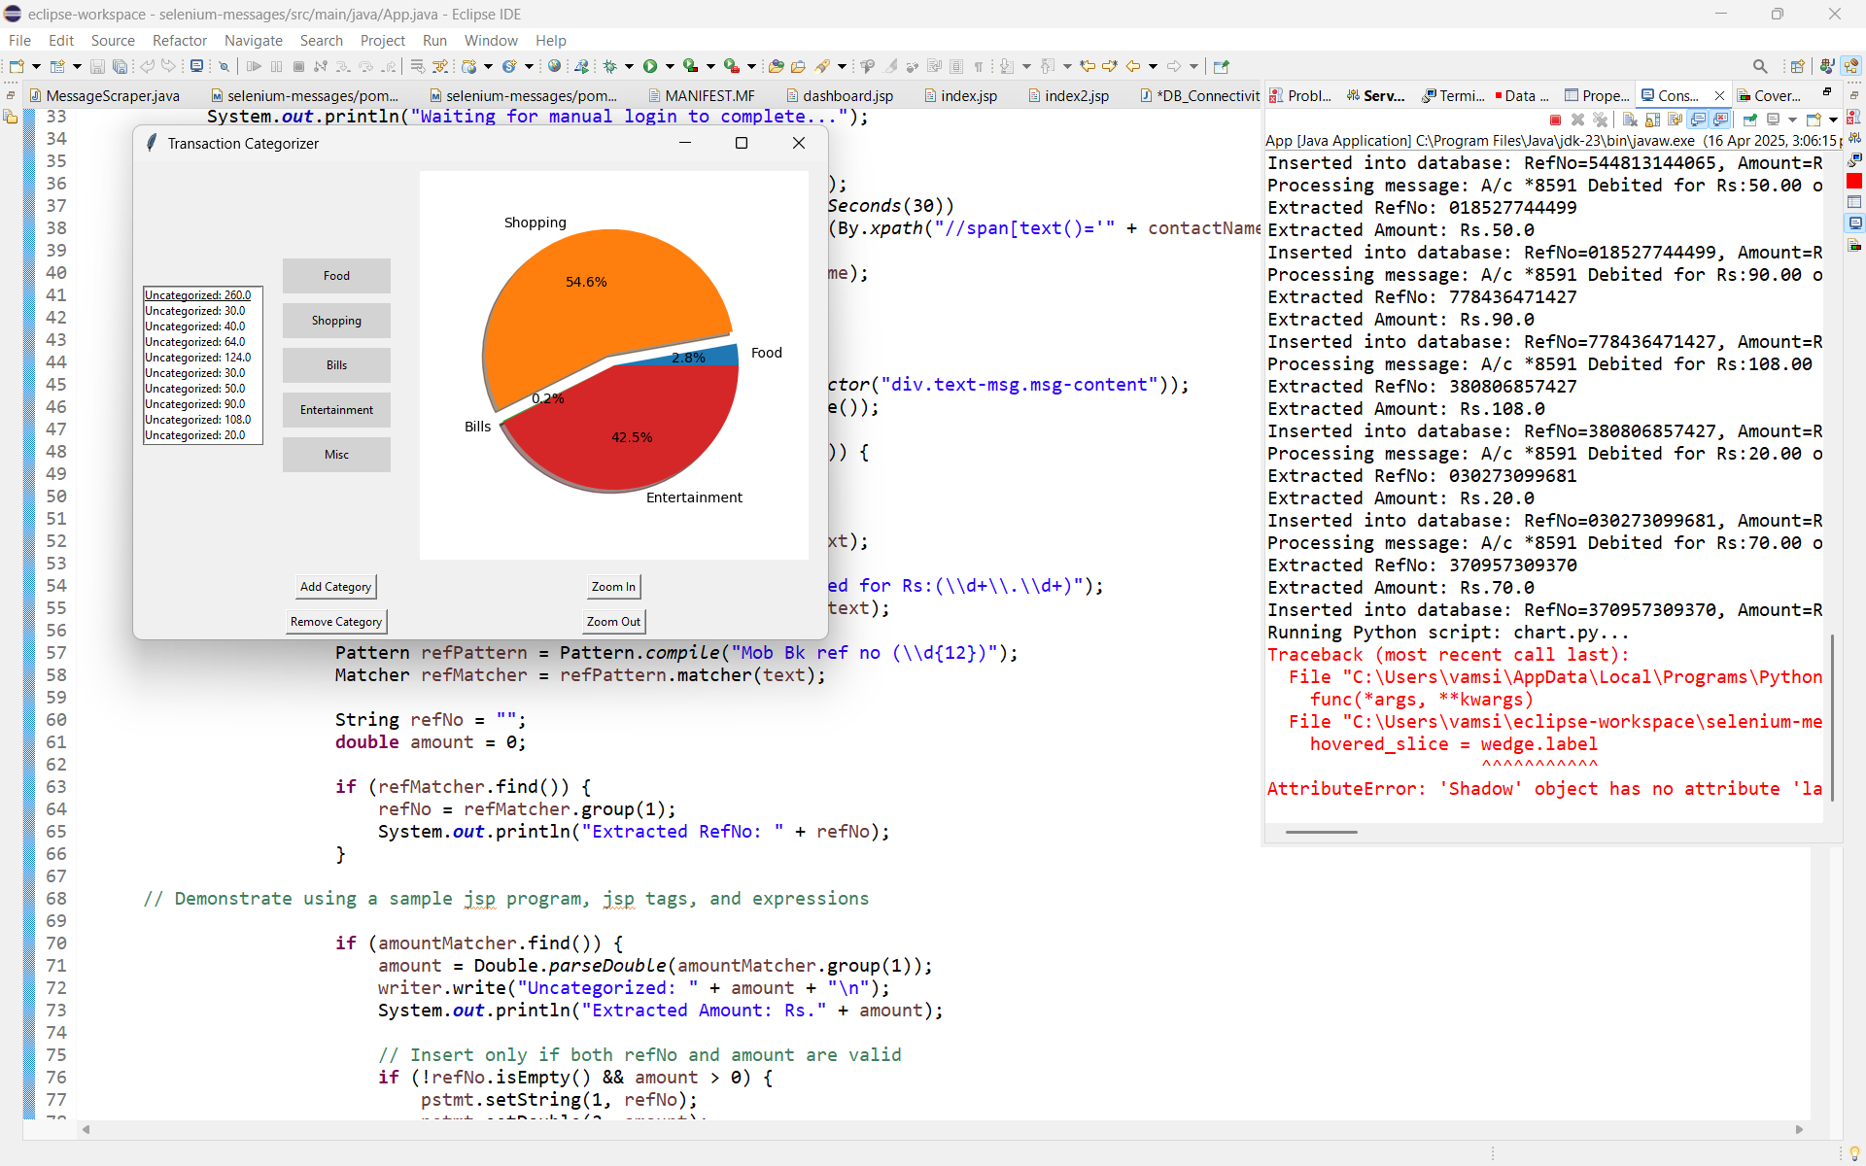

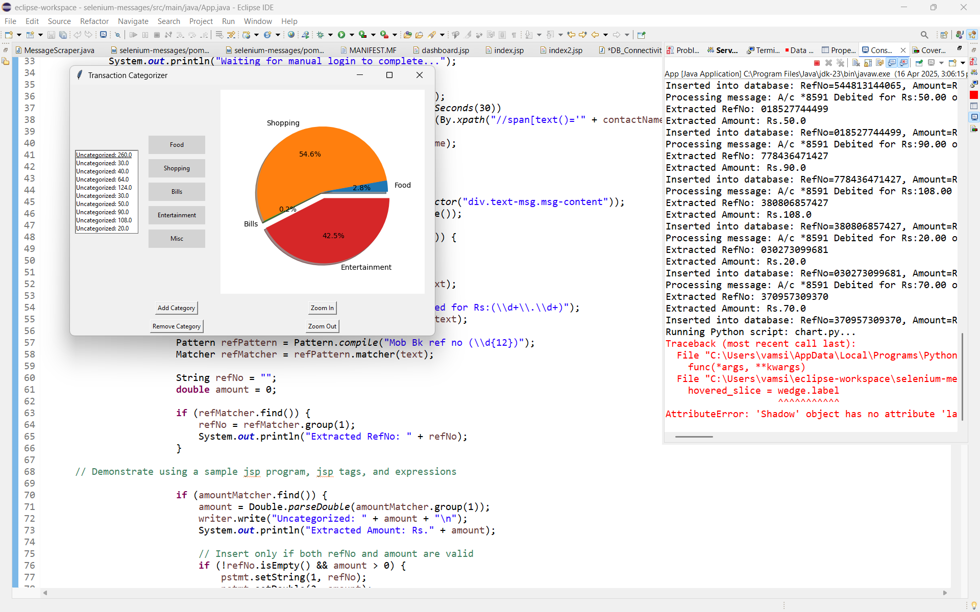

**List of Tables**

| ***Table No.*** | ***Title*** | ***Page No.*** |
| --- | --- | --- |
| *1* | *Income and Expense Categories* | *1* |
| *2* | *Sample Transaction Entries* | *2* |
| *3* | *Monthly Summary Report Format* | *3* |
| *4* | *Category-wise Expense Breakdown Example* | *4* |
| *5* | *Data Storage Structure (CSV/Database)* | *5* |

| **S. No.** | **Feature Name** | **Description** |
| --- | --- | --- |
| **1** | **Add Transaction** | **Add income or expense with category and date** |
| **2** | **Edit/Delete Transaction** | **Modify or remove existing entries** |
| **3** | **View Summary** | **Show total income, expenses, and balance** |
| **4** | **Category Tracking** | **Track spending by categories like food, bills** |
| **5** | **Monthly Report** | **View report for a selected month** |
| **6** | **Data Storage** | **Save data to file or simple database** |

Budget Tracker

1. **1. Introduction**

* Managing personal finances is a challenge for many people, especially students and working individuals. The Budget Tracker project aims to provide a simple and effective tool to help users keep track of their income and expenses. By recording daily transactions and categorizing them, users can gain better control over their spending habits.
* This project is designed to be beginner-friendly and lightweight. It helps users understand where their money is going and encourages better financial planning. The Budget Tracker can be used through a command-line interface or a basic graphical user interface, depending on user preference.

1. **2. Methodology**

The development of the Budget Tracker followed a straightforward approach:

1. **Requirement Gathering**  
   Identify the core features needed: adding transactions, categorization, calculating totals, and storing data.
2. **Tool Selection**  
   Python was chosen for its simplicity. For data storage, CSV or SQLite is used depending on the version (CLI or GUI).
3. **Design Phase**  
   Plan how the user will interact with the app — using menus or buttons. Design basic functions for add, delete, view, and report.
4. **Implementation**  
   Code each feature step-by-step: transaction input, data validation, calculations, and storage. GUI (if used) is built using Tkinter.
5. **Testing**  
   Run tests with various inputs to ensure accurate calculations and reliable data saving.
6. **Output Generation**  
   Display results like total income, expenses, balance, and category-wise reports.

# **CONCLUSION and FUTURE WORK**

### **Conclusion**

The Budget Tracker project successfully provides a basic yet effective way for users to manage their personal finances. It helps track income and expenses, view summaries, and understand spending patterns. With simple features and easy navigation, it proves to be a useful tool for daily financial tracking. The project also serves as a good practice for learning programming concepts like file handling, data management, and UI design.

### **9. Future Work**

Although the current version of the Budget Tracker covers the essential features, there are several areas where it can be improved:

* Add **login system** for multiple users
* Include **data visualization** like pie charts and bar graphs
* Support for **recurring transactions** (e.g., monthly rent, bills)
* Option to **export reports** in PDF or Excel format
* Mobile version or **web-based interface** for accessibility on the go
* Integration with **bank APIs** for auto-importing transactions

These enhancements can make the Budget Tracker a more powerful and user-friendly application in the future.

**Screenshots**

